Northern California Botanists

BARBARA CASTRO

STUDENT (UNDERGRADUATE AND GRADUATE)

BOTANY RESEARCH SCHOLARSHIPS

Application for
Academic Year 2023 - 2024

Deadline: March 15, 2023

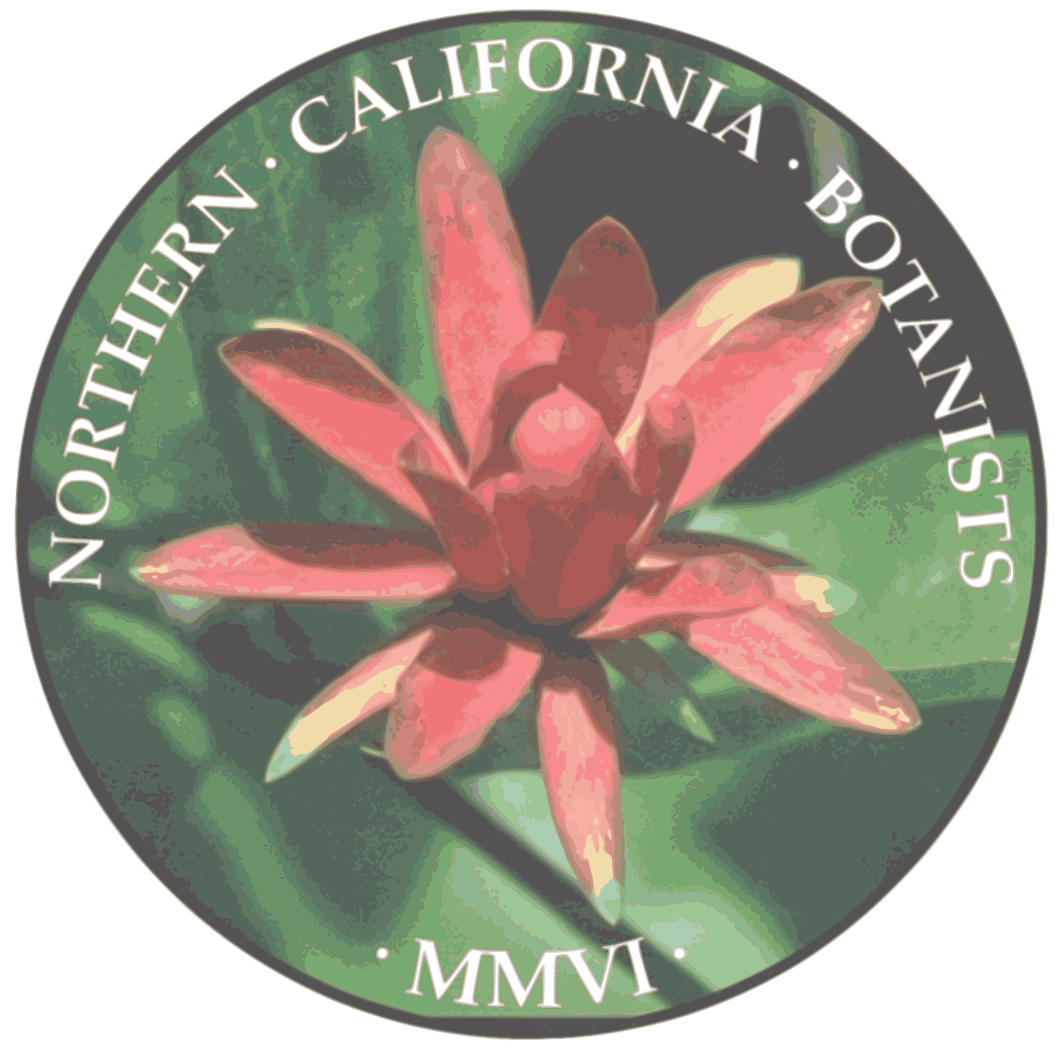

Northern California Botanists

P.O. Box 8042

Chico, California 95927-8042

Northern California Botanists

BARBARA CASTRO

STUDENT (UNDERGRADUATE AND GRADUATE)

BOTANY RESEARCH SCHOLARSHIPS

Northern California Botanists

Northern California Botanists (NCB) is an organization with the purpose of increasing knowledge and communication among agency, consulting, academic, and other botanists about botanical issues concerning science, conservation, education, and professional development. Our primary objectives are to establish a communication forum via occasional meetings, provide a scholarship fund for students working on botanical problems in northern California, provide a job forum, and hold a regular symposium that focuses on the botany of northern California.
Botany Research Scholarship Program

NCB provides competitive botany and plant ecology research scholarships to undergraduate and graduate students who are studying botany and/or plant ecology. Research scholarships will be funded by NCB with the goals of:
- encouraging undergraduate students to pursue academic endeavors toward a career in botany;
- promoting undergraduate and graduate botany and plant ecology research;
- funding botanical research in northern and central California; and
- implementing the objectives of the NCB mission.

Scholarship Awards

Research scholarships consist of $1,000 awards designed to support undergraduate and graduate research. NCB intends to award at least one scholarship in each degree category (undergraduate, master’s, and PhD) as long as qualifying applications meet or exceed application guidelines.

Students may reapply and receive a scholarship award up to a maximum of two years for undergraduates and graduates pursuing a master’s degree, and up to a maximum of four years for graduate students pursuing a doctoral degree. Previous applicants for this award should highlight progress made in the interim period. Awardees must demonstrate satisfactory research and academic progress.

Shasta Chapter California Native Plant Society (CNPS) Award: The Shasta Chapter of CNPS funds one NCB scholarship award per year for an applicant meeting their criteria. The Shasta Chapter Award is in addition to the awards funded by NCB and is to be selected from the same applicant pool using the same evaluation methods as the NCB scholarships. The Shasta Chapter’s additional eligibility criteria are found on their website at www.shastacnps.org/ under “Applications”; these are summarized in Attachment A of this application.
NOTE: Check the criteria for the Shasta Chapter Award in Attachment A or www.shastacnps.org before claiming eligibility. Applicants will be asked to show their eligibility for this award by specifying counties included in research sampling and taxa, or counties of previous residence including high school or community college attended. In addition, applicants must show their eligibility for this award by specifying in as much detail as possible the relevant taxa, locations, and types of sampling or field work to be done within the Shasta chapter’s geographic area. This information should be included in the research summary under a separate subheading ‘Work in Shasta CNPS chapter area’.

Eligibility and Awards Process

Eligibility: The scholarship program is open to undergraduate and graduate students enrolled as full-time students in a college or university performing academic research in botany, plant ecology, or another plant-focused field. Junior and senior undergraduate, master’s, and PhD graduate students are eligible. Primary focus must be plant life (native or non-native) occurring in wildlands of northern California (see geographic range below).

Projects must be part of independent study, thesis, or dissertation coursework.

The geographic reach of the Northern California Botanists (NCB) area of interest for student research scholarships includes the area in California extending northward from the southern boundary of San Luis Obispo County and western slope of the Tehachapi Mountains, following the eastern slope of the Sierra Nevada, to the southern boundary of Mono County. See the map in Attachment B for a graphical depiction of the NCB geographic range. Students from any accredited college or university doing research within the NCB geographic range may apply for NCB student research scholarships. If you are not certain if your study site lies within our area of interest, click here to download a KMZ file that you can view in Google Earth for further clarity on our boundaries.

Be sure to explain how your project will take place at least in part within the geographic area of interest for NCB.

The funded work should occur during the academic year following receipt of this scholarship award (that is, 2023–2024 academic year). Awards will not be granted for work performed in previous years, although the funded work may be part of a multi-year study and include current research. Note: For undergraduates or students in a two-year Master’s program, NCB-funded work can sometimes include research activities which must occur in the spring or summer prior to receipt of an award (i.e., spring-summer 2023).

Application Process for 2023–2024 academic year: Applications must be received by NCB by midnight March 15, 2023. Awards will be announced in May 2023. Funding will normally be provided to awardees in August 2023.

Scholarship Recipient Requirements: Scholarship award recipients are asked to provide a brief synopsis of their research for the NCB Newsletter for award announcement, and to participate in a NCB Symposium, which may include a talk or poster to present the recipient’s supported research project.

Application Guidelines

Applications for the 2023-2024 NCB student research scholarships must be received by NCB by midnight March 15, 2023. Only proposals that involve research on some aspect of northern California plant life (species found in wildlands, not non-native horticultural or crop species) will be considered.

A complete application must include the following:
- Completed application form (found at the end of this document and also at www.norcalbotanists.org/scholarships.htm), including a statement regarding qualification for the Shasta Chapter CNPS scholarship if applicable – provide counties of project work or residence as requested on form.
- Single-page cover letter with brief description of the research and its significance.
- Research proposal not exceeding two to three typewritten pages. The proposal must include the following sections: 1) research summary, 2) study objectives, 3) methods, 4) budget and timeline, and 5) literature cited. Further details are as follows:
  - Research summary and significance: What are you going to be doing? Include a brief summary of the project (this may be in the form of an abstract). The research proposal should contain a statement explaining significance of work. How the research will improve, build on, and/or add to existing knowledge, and how will it contribute to the conservation, restoration or management of natural vegetation communities or plant populations or species. Why is your work important? How will it be useful and to whom?
  - Study goals/objectives: Clearly state the main goals or objectives for the project. These might be in the form of question(s) to be answered, hypotheses, or similar statements, as long as the research focus is concisely worded and clearly identified.
  - Methods: Describe methods simply and clearly, so that reviewers can understand how you are planning to conduct your research, and can evaluate the soundness and feasibility of your research plan.
  - Budget and timeline: The budget should provide an itemized summary of total research costs and notes on how NCB scholarship funds would be spent. For a large or complex project (over $10,000), this section should include the overall budget for the project, and demonstrate that the overall project has secure funding. Clearly identify the portion of the work to be funded by NCB. NCB emphasizes providing funds for direct costs incurred during the course of conducting botanical research—for example, lab supplies, transportation to field sites, field equipment, herbarium research, genetic or statistical analysis. Funding aspects of the project occurring after the research is completed (e.g. presenting at a conference, costs of publication) is not emphasized by NCB. Example budgets for a smaller/ more simple project and a larger/more complex project are provided in Attachment C. Be sure to include a timeline to accomplish goals.
  - Literature cited: Not exceeding one typed page; append this section to your research proposal, using the standard citation style for your field.
  - Previous applicants: Previous applicants to this scholarship should include a short summary of your work since we last heard from you. We care about you and your work, and want to know how you are doing.
- Two recommendations from academic advisors or professionals familiar with your project and your qualifications (at least one must be from an academic advisor). The recommendations should provide insight into your academic potential, research experience, and other information that will help in our review of the application. NOTE: The recommendations need to be submitted as responses to the questions on the form provided by NCB, rather than in a standard narrative letter of recommendation.

Applicants should provide the final version of the scholarship application to each recommender to read before they fill out and submit the form.

The recommendations must be submitted by the recommender by filling out the one-page form provided at www.norcalbotanists.org/scholarships.htm. Each recommender should directly send the form via email to NCB at ncbotanists@gmail.com or mail to P.O. Box 8042, Chico, CA 95927-8042.

All parts of the application materials must be clearly written using correct English grammar and spelling.

Checklist for Scholarship Application

Applicant packet
- Cover Letter
- Application Form
- Research Proposal

All application materials should be submitted to NCB at ncbotanists@gmail.com or to P.O. Box 8042, Chico, CA 95927-8042 by midnight March 15, 2023. Electronic submittal in PDF format is preferred.

Questions?

Questions concerning the preparation and submission of scholarship research proposals and forms, and the administration of this scholarship program, should be directed to Northern California Botanists at ncbotanists@gmail.com or to P.O. Box 8042, Chico, CA 95927-8042.
ATTACHMENT A: Shasta Chapter CNPS Award Criteria

The Shasta Chapter of CNPS funds one NCB Research Scholarship ($1,000). In addition to the general NCB scholarship criteria, the recipient of the Shasta Chapter-funded scholarship must meet at least one of the following two criteria:

- the research topic must include or be directly relevant* to the flora within the boundaries of the Shasta Chapter (Shasta, Lassen, Modoc, and Siskiyou counties), with preference given to topics concerning rare species or communities, or

- the student comes from the Shasta Chapter area. Having graduated from a high school or community college in the Shasta Chapter area is the typical means for demonstrating eligibility under the second alternative.

For criterion (1), order of preference for study-plant taxa or communities will be:
- rare
- not necessarily rare but endemic to Shasta Chapter area
- common CA native plants which also occur in the Chapter area
- invasive weeds known to occur and impact native species in the Chapter area; could be common in the rest of CA or not.

*Relevance should include some specified activity occurring in the Shasta Chapter area – such as sample sites, collections, surveys or other site visits, herbarium specimens, data gathering – spelled out in the application research summary.

ATTACHMENT B
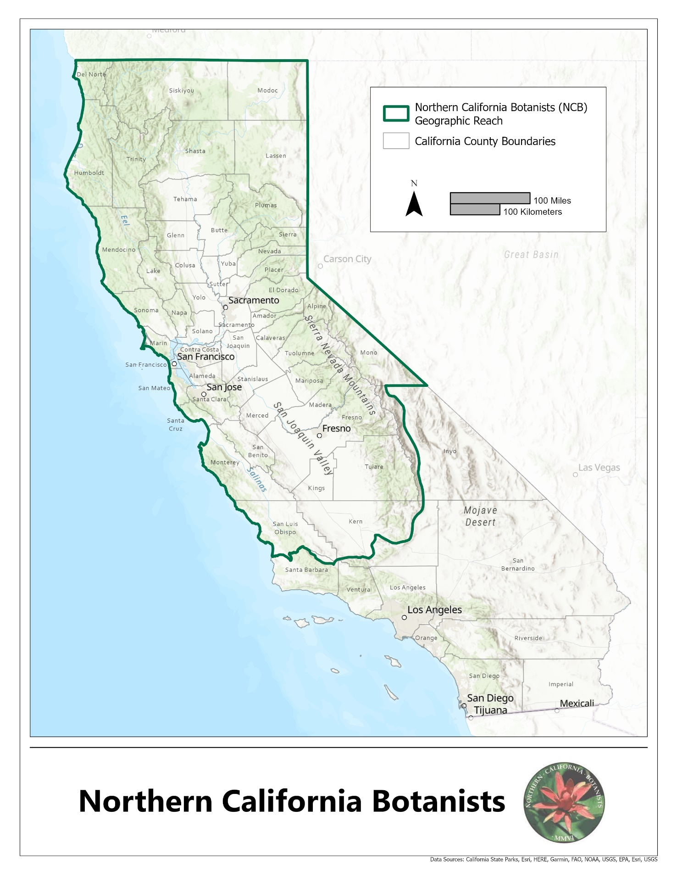

ATTACHMENT C: Example budgets

Note to applicants: These are only examples to give you an idea of what a study budget can look like, not templates to follow. Especially for Example 2 for the more complex study, the budget itemizing does not necessarily need to be as detailed, and the supplemental sources of funding do not necessarily need to be as explicit. Mostly we want to know that you have considered what your project will cost to carry out, that your expenses total at least the amount of the award, and are reasonable.

NOTE: ITEMS NOT FUNDED BY NCB SCHOLARSHIPS:
1. Everyday living expenses (e.g., rent or regular housing expenses, groceries, utility bills, etc.)
2. Other ongoing expenses not specifically related to the research project.
3. Academic tuition and/or student loans.

TYPICAL ITEMS FUNDED BY NCB SCHOLARSHIPS
[not intended to be an exhaustive list – just common examples of direct costs of research]
1. Lab supplies
2. Field equipment
3. Transportation to field sites
4. Herbarium research
5. Genetic or statistical analysis
6. Camping/lodging fees, food, supplies at remote field sites
7. Field assistant stipends

Example 1: Smaller/More Simple field project
SAMPLE BUDGET – The total cost of my field project is expected to be $1,250. Any funds awarded for this proposal will be used for funding field research to be performed in the 2018-2019 academic year. The table below contains a summary of my expenses.

SUPPLIES
PVC and glue for sampling frames | $200
Wire screen | 150
Rite in Rain notebook | 25
Marking flags | 75
Total supplies | $450
FIELD TRAVEL
Mileage (1000 miles @$0.50 per mile) | $500
Camping (6 nights @$25 per night) | 300
Total travel | $800
TOTAL PROJECT | $1,250

Example 2: Larger, multi-phase project with field and lab component
SAMPLE BUDGET AND JUSTIFICATION - Any funds awarded for this proposal will be used entirely toward the funding of my final round of ddRADseq, which will be performed in the 2017-2018 academic year. An outline of my expenses and funding is provided in the table below. A final grant proposal was submitted to the Botanical Society of America on March 15. My adviser, through grant funds, provided additional funding for this research.

CONTRIBUTION TO LAB REAGENTS & SUPPLIES
Lab Notebooks (2) | $30
Gloves (Box of 10 Packs) | $210
Pipette Tips (bulk bags in 3 sizes) | $97
Microcentrifuge Tubes (1 bulk bag) | $20
Silica Gel | $60
LAB SUPPLIES TOTAL | $417
SEQUENCING
Library preparation (33 samples @ $86/sample) | $2,838
Contribution to shared Illumina lane | $330
RADseq QC/Fragment analysis/Lib Prep (71 samples)* | $852
Illumina Sequencing of RAD library (1 lane) | $1,550
SEQUENCING TOTAL | $5,570
FIELDWORK
Southern California
- Mileage (53 @ $0.30/mi) | $16
Central and northern California
- Mileage (1,137 @ $0.30/mi) | $341
- Camping (5 nights @ $25/night) | $125
- Food (5 days @ $25/day) | $125
FIELDWORK TOTAL | $607
PROJECT TOTAL | $6,594
FUNDING TO DATE
California Native Plant Society, 2013 | $850
American Society of Plant Taxonomists, 2014 | $800
California Native Plant Society, 2014 | $400
Southern California Botanists, 2015 | $1,000
Advisor Lab Fund (to date) | $1,120
FUNDING TO DATE | $4,175
*The $1,000 NCB Award would be used to fund RADseq.

Northern California Botanists

BARBARA CASTRO

STUDENT BOTANY RESEARCH SCHOLARSHIPS

Academic Year 2023-2024

Academic Year 2008-2009

APPLICATION FORM

Name:__________________________________________________________________

Current Address ________________________________________________________

City ___________________________State ______________Zip____________

Telephone_________________ Email _________________________________

Project Title ____________________________________________________________

_______________________________________________________________________

College or University (2022-2023) __________________________________________

Declared Major: _________________________________________________________

______ Undergraduate ______ Graduate (MS) ______ Graduate (PhD)

SHASTA CNPS CHAPTER AWARD ELIGIBILITY (check box if appropriate, see Attachment A):
I am eligible based on
Research Relevant to CNPS Shasta Chapter Area. On the line below, list counties within Shasta chapter area in which your research will occur: ______________________________________________
AND/OR
I am from the Shasta Area. On the line below, list city/county within Shasta chapter area of previous residence including name of high school or community college attended: _____________________________________________________________________________

RECOMMENDATIONS
Faculty Advisor _____________________________ Title _____________________________

Department _________________________________ Email ______________________ ______

Additional Reference:

Name:______________________________________ Title _____________________________

Affiliation:__________________________________ Email ____________________________

Undergraduate juniors and seniors, and graduate students are eligible. Projects must be part of independent study, thesis, or dissertation coursework to occur in academic year following receipt of scholarship funds.
Applications must be received by NCB no later than midnight March 15, 2023 at ncbotanists@gmail.com or Northern California Botanists, P.O. Box 8042, Chico, CA 95927-8042.

